**Unity C# Advanced**

**LAB # 10**



**Fall 2024**

**CSE-411L Intro to Game Development Lab**

Submitted by: **Ali Asghar**

Registration No.: **21PWCSE2059**

Class Section: **A**

“On my honor, as student of University of Engineering and Technology, I have neither given nor received unauthorized assistance on this academic work.”

Submitted to:

**Engr. Abdullah Hamid**

Date:

**17th January 2025**

**Department of Computer Systems Engineering**

**University of Engineering and Technology, Peshawar**

**Objective:**

In this lab we further explored the Unity API.

**Tasks:**

* Create a new Unity scene.
* Add a simple plane to serve as the ground in the scene.
* Use character models from Mixamo.com to create a player and an enemy.
* Both the player and the enemy characters should have walk, idle, and punch animations.
* When the game starts, the enemy should follow the player if the distance between them is less than 5 units.
* When the enemy gets close enough to the player, it should trigger the punch animation.
* The player should also be able to trigger the punch animation.
* Use delegates in such a way that:
* Pressing **Mouse0** and **Q** triggers the player’s punch animation.
* Pressing **Mouse0** and **W** triggers another animation, such as a kick.

**Code:**

PlayerController class

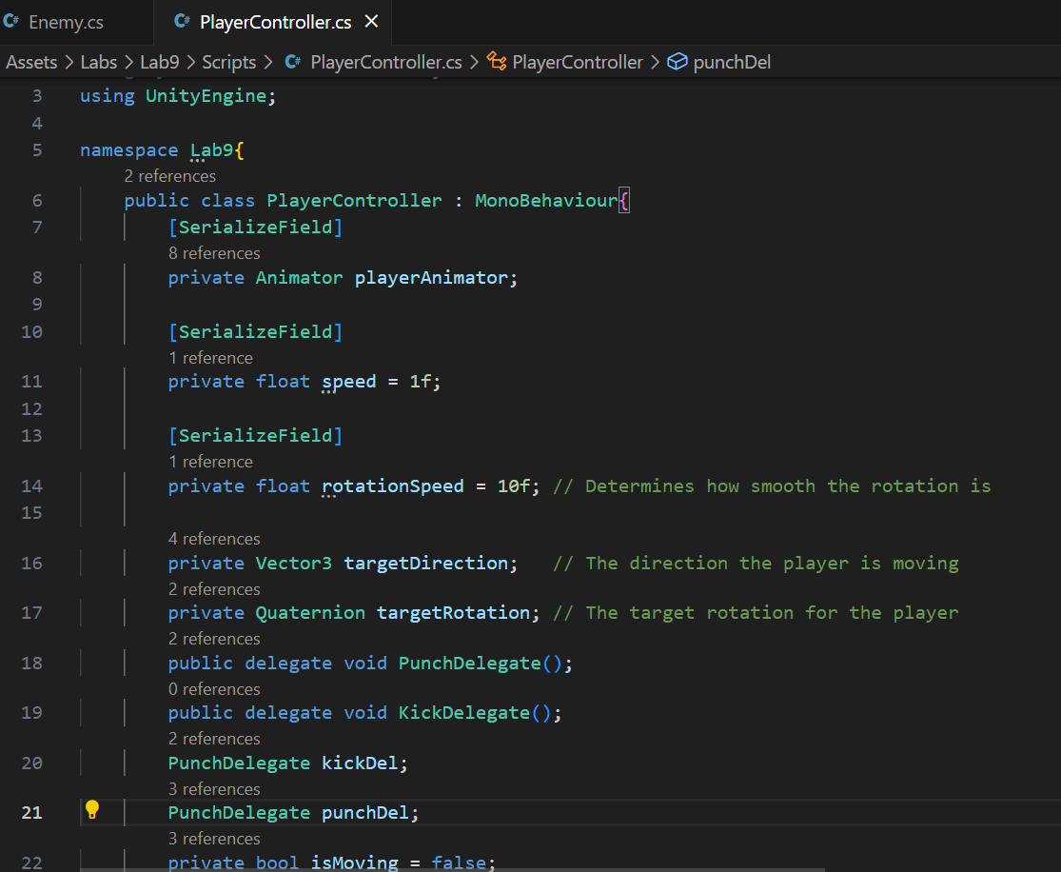

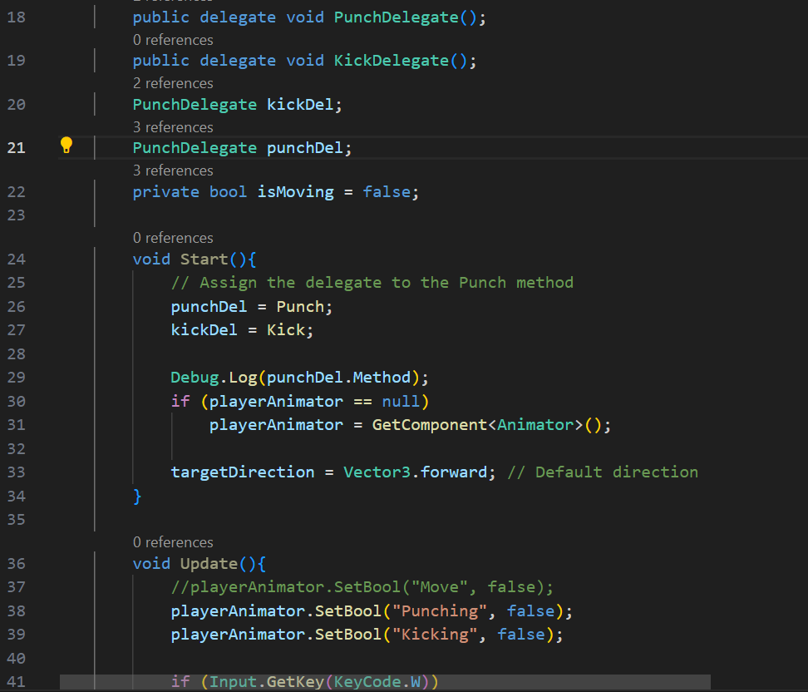

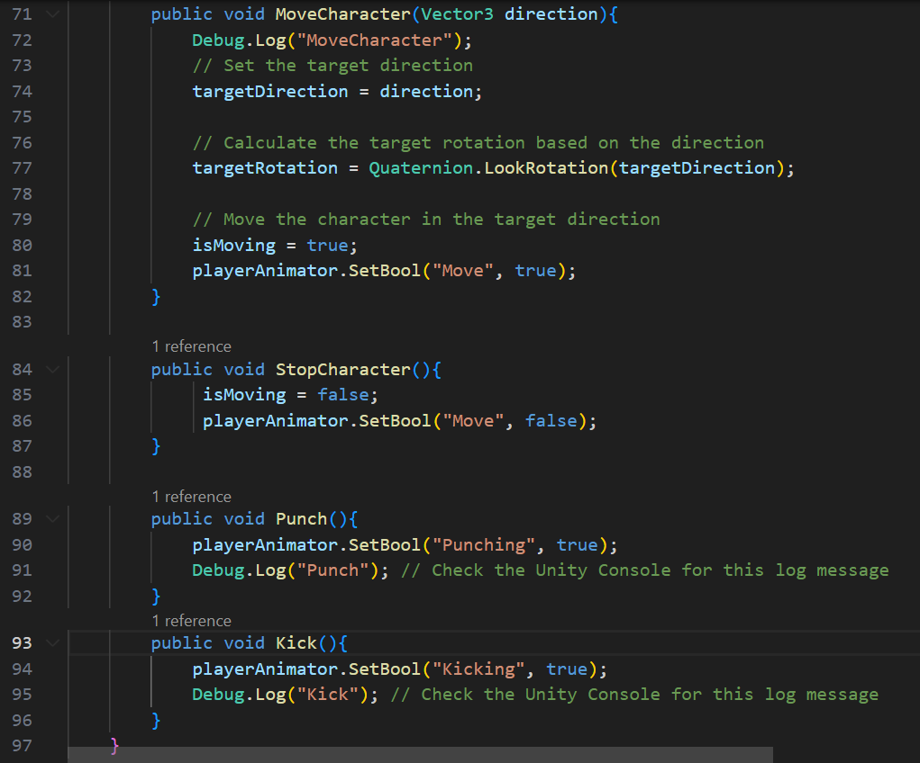

PlayerInputs class

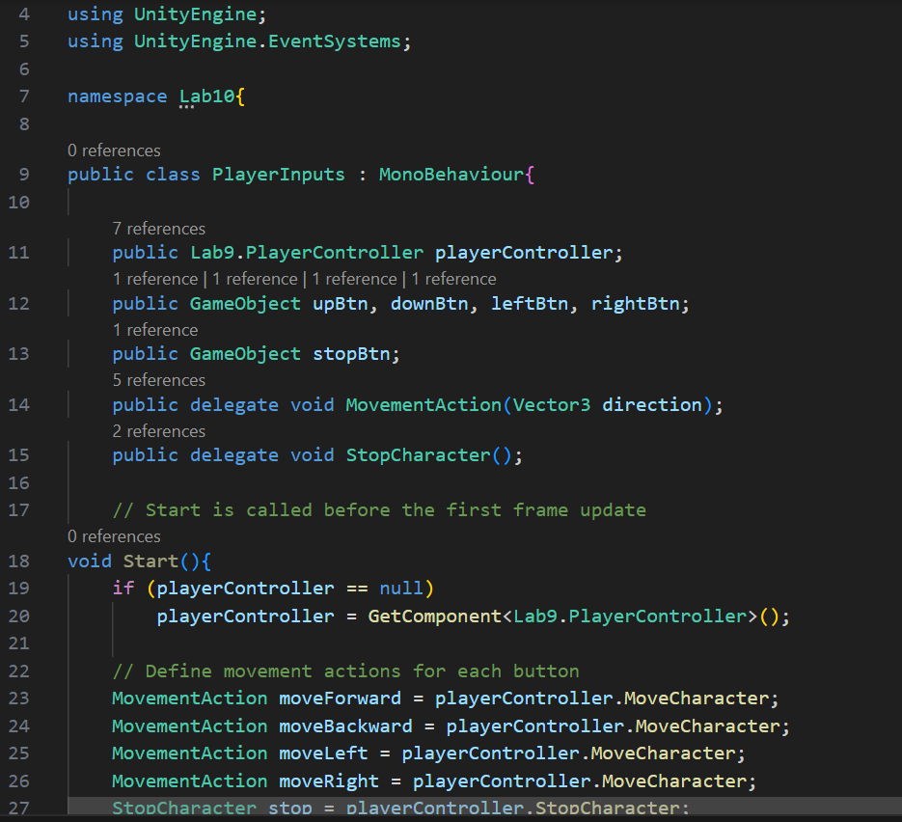

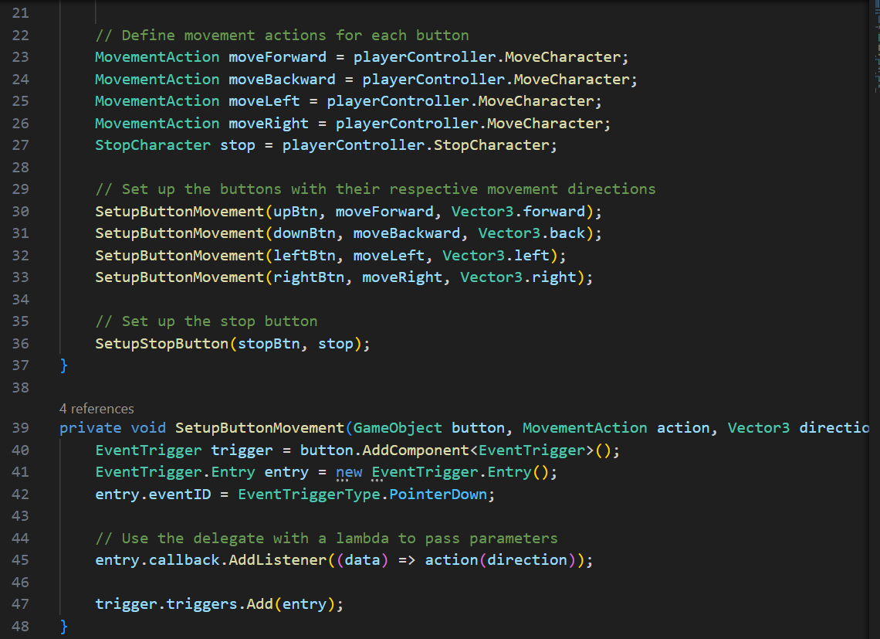

Enemy class

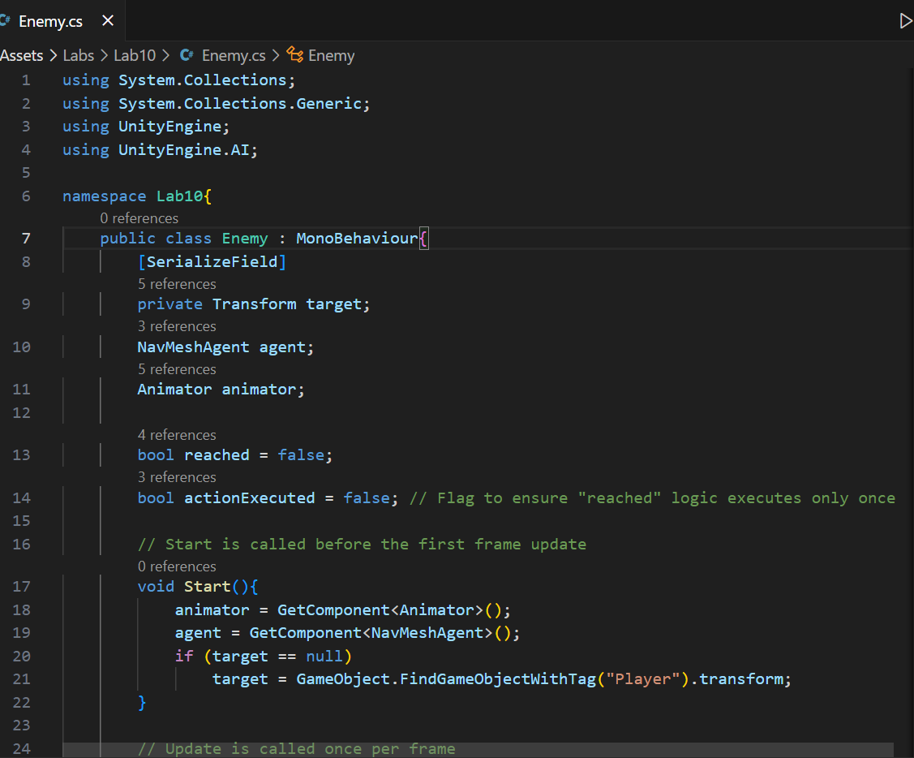

**Player Animator FSM:**

**Enemy Animator FSM:**

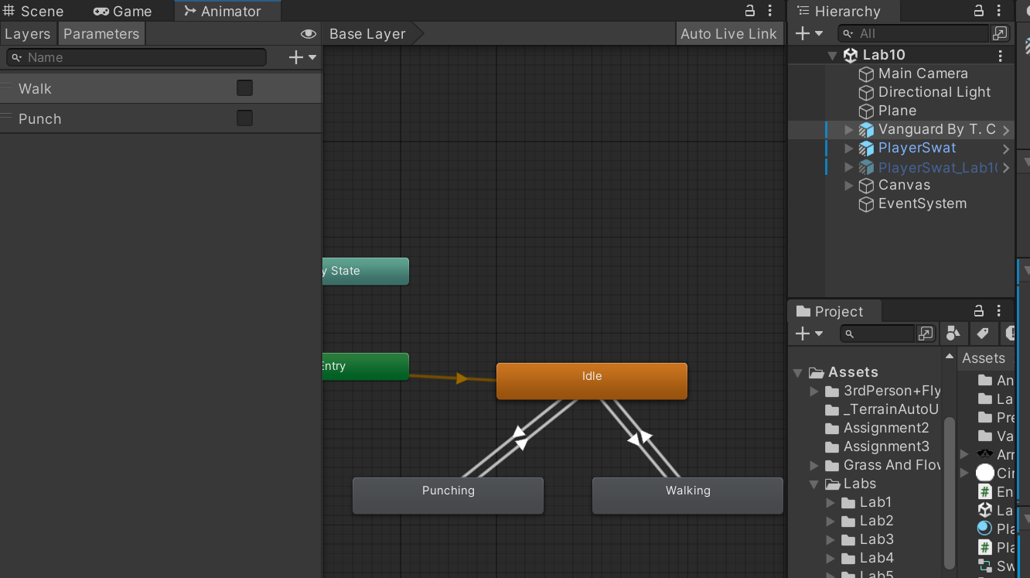

**Output:**



